**CS 2340 – Spring 2023**

Group # 71

Professor Watson-Phillips

Sprint 1 Design Deliverables

**Nouns**

* Player
  + Name
* River
* Road
* Vehicle
* Log
* Goal
* Start
* Lives
* Scoreboard
* Stopwatch
* Speed of Object

**Conceptual Classes**

* **Player**
  + Name
  + Image – Frog
  + Score
* **GameState**
  + Difficulty
  + Score
  + High score
* **River**
  + Current
  + Color
  + Size (pixels)
* **Road**
  + Color
  + Size (pixels)
  + # of Lanes
* **Lanes**
* Type of Lane (i.e, truck, car)
* Size
* Screen position
  + **Vehicle**
    - Truck
      * Direction – left or right
      * Speed
      * Image
    - Car
      * Direction – left or right
      * Speed
      * Image
  + **Log**
    - Size
    - Direction – left or right
    - Speed
    - Image
    - On screen position
  + **Alligator**
    - Damage
    - Direction
    - Image
  + **Water Snake**
    - Damage
    - Direction
    - Image
* **Goal**
  + Color
  + Image
  + Size
* **Sidewalk**
  + isStart (boolean)
  + Color
  + Size (pixels)

**Use Case Diagram**

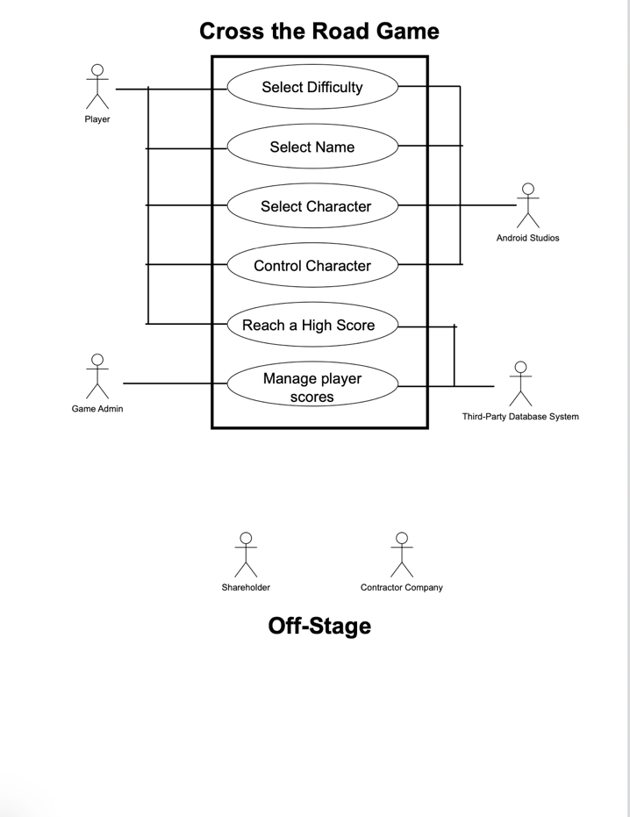

**Domain Model Diagram**

